Dreams and passion


"Every great dream begins with a dreamer. Always remember, you have within you the strength, the patience, and the passion to reach for the stars to change the world."
What is Dream?
We only lived once.Every human being have many desires.we all want something
At every stage of life.In childhood some people wants toffees and want to play all day,in adolescence we want freedom and wants self identity,in adulthood we want Carrier stability, partner companionship.
some desire gives us temporary pleasure..like we all want to watch our
Favourite,some wants tasty foods,some wants visit a beautiful destination.
But When we talk about Dreams it's totally different.Dreams gives us permanent happiness and sense of fulfillment.



Dreams makes us alive.We can say it's our true calling. Passion is more and less similar to Dreams. Passion means A work a human being can do without getting tired.If someone passion is music.they can listen and Sing music for hours.

How to know what is your dream and passion?

I saw many people quite confused and thinking about several questions-
1.what is my dreams?
2.what is my objective in my Life?why am I Alive?what is purpose of my life?
These questions makes some people awake for hours in night।when they did not get their answers they will frustrated and feel worthless for Life time.
So Their are many ways to know about your dreams and passion.some methods are-
Alone time and Journaling are the ultimate medium to know about your passion.
Your passion may be right in front of you.in other cases people are too occupied with drama busy work for addiction of the modern world that their mind becomes polluted that's why you need a long time and journalising you can ask following question to yourself
1. what drives you?
2. What truly matters to you?
3. What you always want to do?
4. What brings fulfillment in your life?
5. How do you want to bring value to people's lives?
You can do other things like..
1.attend lecture of motivational speakers
2.Give personality or aptitude test
3.search and find in real word
4.Create and give a try(Don't hesitate)
You are not here to use your phone for hours.Just following the queue of all others will never make you reach to place you want.we all have some purpose in life.
In life a lot we can do,a lot we should do.
How to achieve your goals and fulfill your Dreams?
When you find what you want to do.what is your true calling.
Now it's time to give your efforts, time to achieve your goals.
Follow things keep in mind-
Planning and Set your Goal
Most of successful people had plan for their Dreams.you also need to plan.where you are..where you want to go? it'simportant to have a vision everyday you wake up from the bed to wake up for a purpose .purpose to fulfill your duties. purpose to actualize your dreams.write down your boss or work you need to do throughout the day. penning down such things can someone help you to ready to face all the further of obstacles.break down your goals into small pieces.When you break down your goals it seems to easy to achieve them.It is actually what you need..You just need some motivation and push up.. planning and set small goals will definitely help you.


2.Constant effort and try to Give your Best
You need to Devote your Hardwork and time for your passion.doesn't matter how busy you are you just have to manage your time and give some time to your dream. You know
slow and steady wins the race
Consistency is that the fuel of vehicle 'Success' which note move a step ahead without it.To become truly mind-blowing and Excellent at whatever your dream is,you need consistency.As a student we all are facing same conditions and pressure.But you don't need to overthink.It is just a stage of life.All worries and attachments are temporary.It is only your dreams which helps you to meet your self.

3.Be positive and Stay motivated
When you trying and keep giving your best.you also need to stay positive.
Ups and downs are part of life.So don't take so much tension.Be an optimist, Dream Big,most important believe in yourself.You deserve what you want.Always remember no can motivate you more than you.
Sometime you can also take a SMALL break, enjoy your life.Don't feel guilty that you are wasting your time when you are attending Birthday party and any wedding or going for a vacation.
This Breaks also give you positivity and new enthusiasm.

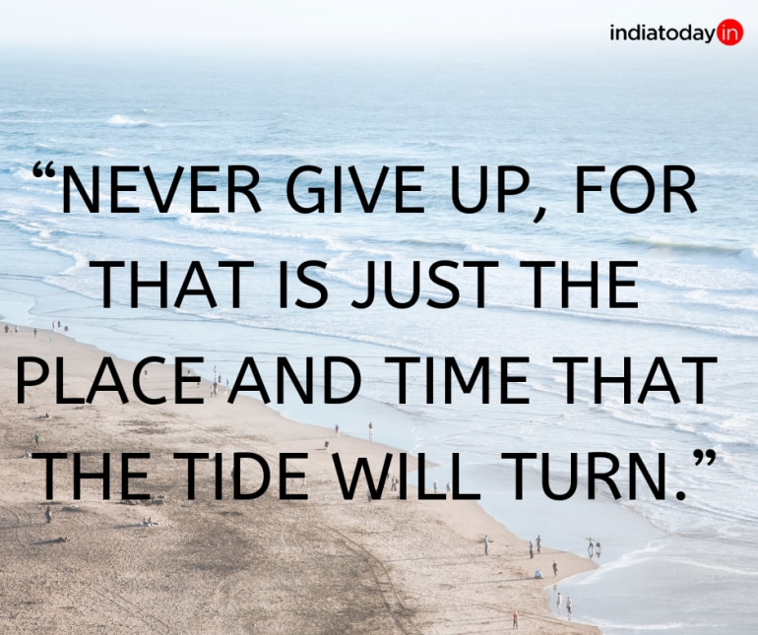

4.Accept your failures as well
Journey of success is like rolarcoster ride.you fall down sometime or you don't get desirable results.Then you feel worthless and Feel like let's give up.But wait my friend,what are you doing?
Remember why you started all this?

Because you yes you
You want to live your life.you want to be happy.You want to feel good.
How can you easily give up.Failure is not the end.Think about passion..And don't let anything pull you down now.
5.live it for yourself
For a day,think what you need in life.when you get old,it is too late too feel upset and said that I can't do what I always wanted to do.it's too late.
So now you have time..for e.g. if you want to Do something for a society.you start trying to find ways.it's your responsibility to find ways.Grab every opportunity that knock your door.

Whenever you are, whatever you are doing ..keep Dreaming and keep trying.
All the best.🌼

.

